Arduino e visual basic

Codice VB per far accendere o spegne due led
Public Class Form1
Shared _continue As Boolean
Shared _serialPort As SerialPort

Private Sub Form1_Load(sender As Object, e As EventArgs) Handles MyBase.Load
SerialPort1.Close()
Attenzione alla scelta della porta com. Inserire prima la seriale per vedere su quale porta il pc sta comunicando. Dopo ciò si può correggere il codice in vb mettendo la porta opportuna
SerialPort1.PortName = "com7"
SerialPort1.BaudRate = 9600
SerialPort1.DataBits = 8
SerialPort1.Parity = Parity.None
SerialPort1.StopBits = StopBits.One
SerialPort1.Handshake = Handshake.None
SerialPort1.Encoding = System.Text.Encoding.Default
End Sub

Private Sub Button1_Click(sender As Object, e As EventArgs) Handles Button1.Click
SerialPort1.Open()
SerialPort1.Write("0")
SerialPort1.Close()
End Sub

Private Sub Button2_Click(sender As Object, e As EventArgs) Handles Button2.Click
SerialPort1.Open()
SerialPort1.Write("1")
SerialPort1.Close()
End Sub

Private Sub Button3_Click(sender As Object, e As EventArgs) Handles Button3.Click
SerialPort1.Open()
SerialPort1.Write("2")
SerialPort1.Close()
End Sub

Private Sub Button4_Click(sender As Object, e As EventArgs) Handles Button4.Click
SerialPort1.Open()
SerialPort1.Write("3")
SerialPort1.Close()
End Sub

Private Sub Button5_Click(sender As Object, e As EventArgs) Handles Button5.Click
SerialPort1.Open()
SerialPort1.Write("4")
SerialPort1.Close()
End Sub
End Class

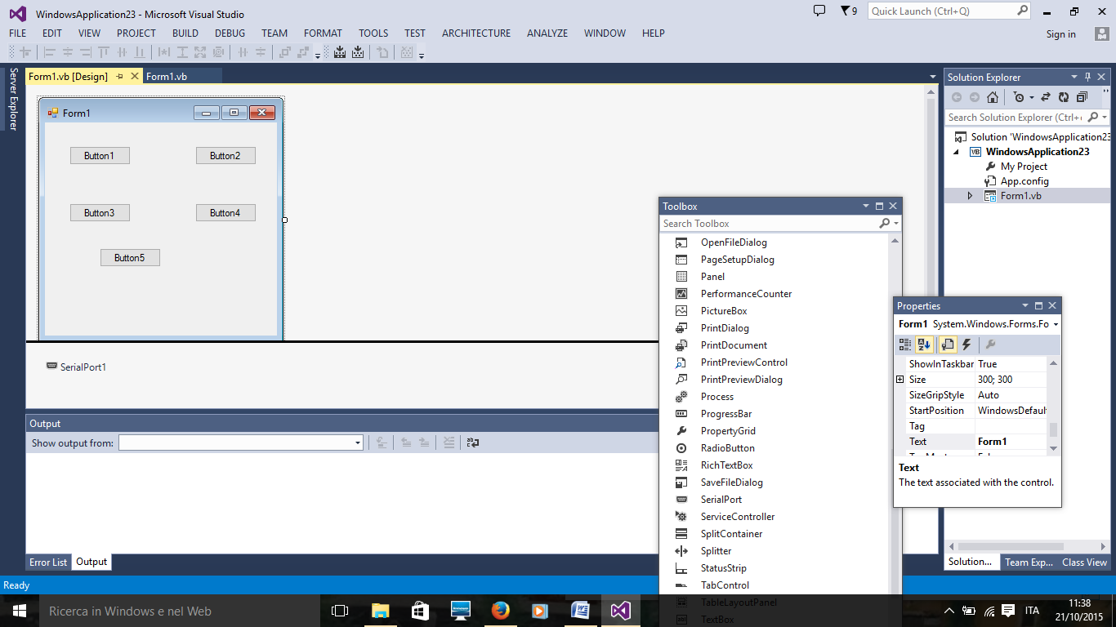
Attenzione ad inserire SerialPort1

Codice Arduino
void setup()
{
pinMode(4,OUTPUT);
pinMode(5,OUTPUT);
Serial.begin(9600);
}

void loop()
{
int comando;
if (Serial.available()){
delay(100);
while(Serial.available()>0){
comando=Serial.read();
if(comando=='0')
digitalWrite(4,LOW);
if(comando=='1')
digitalWrite(4,HIGH);
if(comando=='2')
digitalWrite(5,LOW);
if(comando=='3')
digitalWrite(5,HIGH);
if (comando=='4'){digitalWrite(4,LOW);
digitalWrite(5,LOW);
}
}
}
}

