Arduino e visual basic

Codice VB per far accendere o spegne due led

Imports System.IO
Imports System.IO.Ports
Imports System.Threading
Public Class Form1
Shared _continue As Boolean
Shared _serialPort As SerialPort

Private Sub Form1_Load(sender As Object, e As EventArgs) Handles MyBase.Load
SerialPort1.Close()
Attenzione alla scelta della porta com. Inserire prima la seriale per vedere su quale porta il pc sta comunicando. Dopo ciò si può correggere il codice in vb mettendo la porta opportuna
SerialPort1.PortName = "com7"
SerialPort1.BaudRate = 9600
SerialPort1.DataBits = 8
SerialPort1.Parity = Parity.None
SerialPort1.StopBits = StopBits.One
SerialPort1.Handshake = Handshake.None
SerialPort1.Encoding = System.Text.Encoding.Default
End Sub

Private Sub Button1_Click(sender As Object, e As EventArgs) Handles Button1.Click
SerialPort1.Open()
SerialPort1.Write("0")
SerialPort1.Close()
End Sub

Private Sub Button2_Click(sender As Object, e As EventArgs) Handles Button2.Click
SerialPort1.Open()
SerialPort1.Write("1")
SerialPort1.Close()
End Sub

Private Sub Button3_Click(sender As Object, e As EventArgs) Handles Button3.Click
SerialPort1.Open()
SerialPort1.Write("2")
SerialPort1.Close()
End Sub

Private Sub Button4_Click(sender As Object, e As EventArgs) Handles Button4.Click
SerialPort1.Open()
SerialPort1.Write("3")
SerialPort1.Close()
End Sub

Private Sub Button5_Click(sender As Object, e As EventArgs) Handles Button5.Click
SerialPort1.Open()
SerialPort1.Write("4")
SerialPort1.Close()
End Sub
End Class

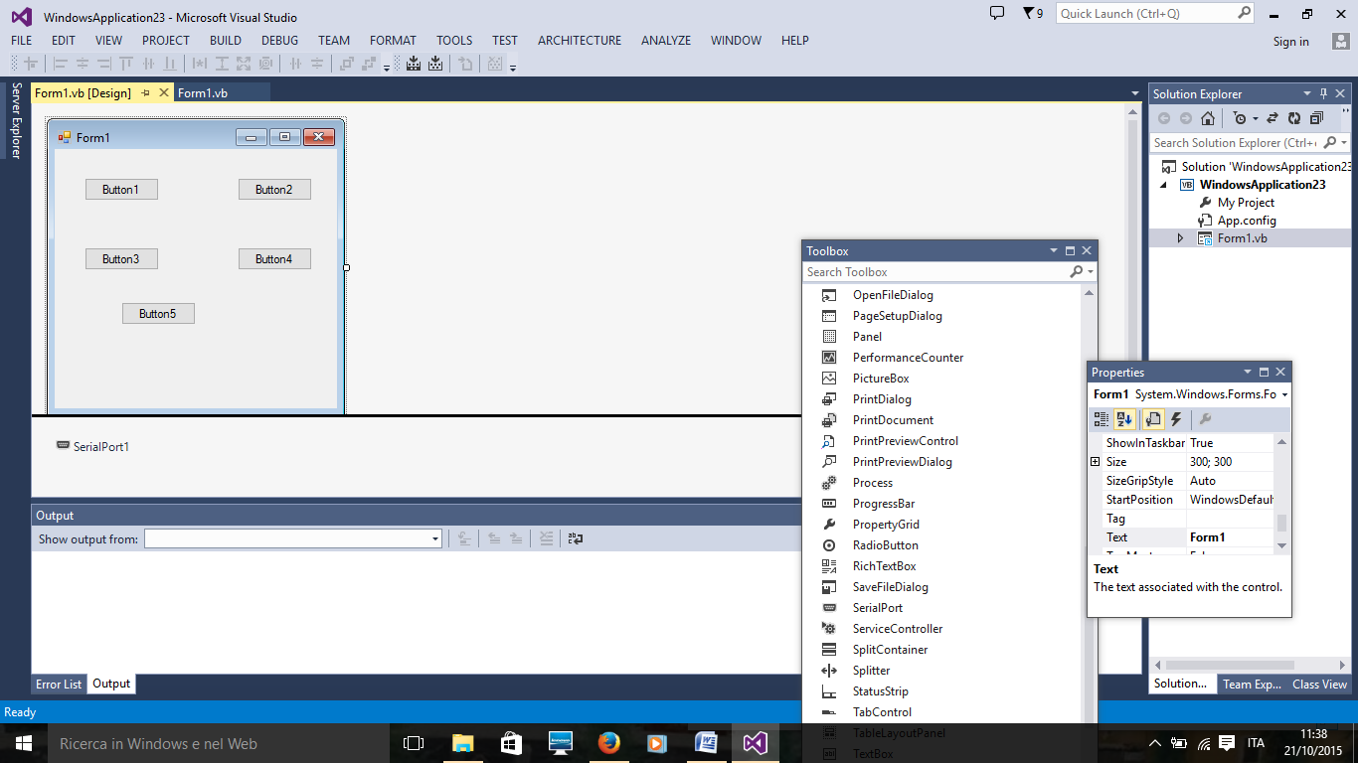
Attenzione ad inserire SerialPort1

Codice Arduino
void setup()
{
pinMode(4,OUTPUT);
pinMode(5,OUTPUT);
Serial.begin(9600);
}

void loop()
{
int comando;
if (Serial.available()){
delay(100);
while(Serial.available()>0){
comando=Serial.read();
if(comando=='0')
digitalWrite(4,LOW);
if(comando=='1')
digitalWrite(4,HIGH);
if(comando=='2')
digitalWrite(5,LOW);
if(comando=='3')
digitalWrite(5,HIGH);
if (comando=='4'){digitalWrite(4,LOW);
digitalWrite(5,LOW);
}
}
}
}

Imports Microsoft.Office.Interop.Excel
Public Class Form1
Dim ora(24) As String
Dim temperatura(24) As Decimal
Private Sub Form1_Load(sender As Object, e As EventArgs) Handles Me.Load
SerialPort1.Close()
SerialPort1.PortName = "COM3"
SerialPort1.Open()
DataGridView1.ColumnCount = 1
DataGridView2.ColumnCount = 1
End Sub

Private Sub Button1_Click(sender As Object, e As EventArgs) Handles Button1.Click
SerialPort1.WriteLine("A")
Dim i As Integer
i = 0
Do While i <= 23
ora(i) = i + 1
DataGridView1.Rows.Add(ora(i))
i = i + 1
Loop

Dim j As Integer
j = 0
Do While j <= 23
temperatura(j) = SerialPort1.ReadLine
DataGridView2.Rows.Add(temperatura(j))
j = j + 1
Loop
Button2.Visible = True
End Sub

Private Sub Button2_Click(sender As Object, e As EventArgs) Handles Button2.Click

Dim programma As Application
Dim cartella As Workbook
Dim foglio As Worksheet
Dim percorso As String
percorso = ("E:\VisualBasic\ArduinoExcel\Cartel3.xlsm")
programma = CreateObject("excel.application")
cartella = programma.Workbooks.Open(percorso)
programma.Visible = True
foglio = cartella.ActiveSheet
Dim rig As Integer
rig = 0
Do While rig <= 23
foglio.Cells(1, 1) = "Ora"
foglio.Cells(1, 2) = "Temperatura"
foglio.Cells(rig + 2, 1) = ora(rig)
foglio.Cells(rig + 2, 2) = temperatura(rig)
rig = rig + 1
Loop
End Sub
End Class

III Progetto

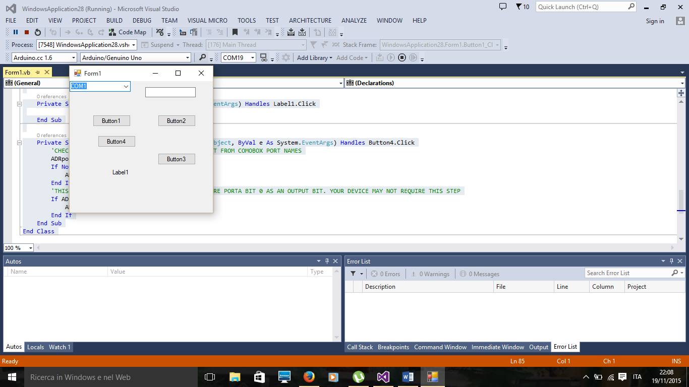
Imports System
Imports System.IO.Ports
Imports System.Threading

Public Class Form1
'DECLARE A COMM PORT
Dim WithEvents ADRport As SerialPort = New _
System.IO.Ports.SerialPort("COM19")

' , _9600, _Parity.None, _8, _StopBits.One)

Private Sub Form1_FormClosed(ByVal sender As Object, ByVal e As System.Windows.Forms.FormClosedEventArgs) Handles Me.FormClosed
'CHECK IF PORT IS OPEN AND THEN CLOSE COMM PORT
If ADRport.IsOpen Then
ADRport.Close()
End If
End Sub

Private Sub Form1_Load(ByVal sender As System.Object, ByVal e As System.EventArgs) Handles MyBase.Load
'CREATE 20 COM PORTS TO BE SELECTIONS IN PULL DOWN MENU
Dim PortCount As Integer
For PortCount = 1 To 20
ComboBox1.Items.Add("COM" & PortCount)
Next
'SET COMBO BOX TO COM 1 (DEFAULT)
ComboBox1.SelectedIndex = 0
End Sub

Private Sub Button1_Click(sender As Object, e As EventArgs) Handles Button1.Click
Try
'SEND "RDO" + CR OUT ON RS232 Port
ADRport.Write("RD0" + Chr(13))
'WAIT 20MS FOR COMMAND TO BE SENT
Thread.Sleep(20)
'SET READ TIMOUT FOR RS232 READ TO 100MS
ADRport.ReadTimeout = 100
'READ DATA FROM RS232 INPUT BUFFER UP TO THE NEXT CR ( CHR(13))
TextBox1.Text = (ADRport.ReadTo(Chr(13)))

Catch ex As TimeoutException
'IF THERE IS A TIMEOUT, PRINT" No Data " IN TEXTBOX1.TEXT
TextBox1.Text = "NoData"
'THE NEXT LINE ENABLES A SPLASH SCREEN WITH AN ERROR MESSAGE ( DELETE IF NOT DESIRED)
MsgBox(ex.Message)
End Try

End Sub

Private Sub Button2_Click(sender As Object, e As EventArgs) Handles Button2.Click
'SEND "SETPA0" COMMAND TO ADR112 TO SET PORT A, bit 0
ADRport.Write("SETPA0" + Chr(13))

End Sub

Private Sub Button3_Click(sender As Object, e As EventArgs) Handles Button3.Click
'SEND "RESPA0" COMMAND TO ADR112 TO RESET PORT A, bit 0
ADRport.Write("RESPA0" + Chr(13))

End Sub
Public Sub New()
' This call is required by the designer.
InitializeComponent()
' Add any initialization after the InitializeComponent() call.
End Sub

Private Sub Label1_Click(sender As Object, e As EventArgs) Handles Label1.Click

End Sub

Private Sub Button4_Click(ByVal sender As System.Object, ByVal e As System.EventArgs) Handles Button4.Click
'CHECK IF PORT IS CLOSED AND THEN OPEN COM PORT FROM COMOBOX PORT NAMES
ADRport.PortName = ComboBox1.SelectedItem
If Not ADRport.IsOpen Then
ADRport.Open()
End If
'THIS SET IS REQUIRED BY THE ADR112 TO CONFIGURE PORTA BIT 0 AS AN OUTPUT BIT. YOUR DEVICE MAY NOT REQUIRE THIS STEP
If ADRport.IsOpen Then
ADRport.Write("CPA11111110" + Chr(13))
End If
End Sub
End Class

IV progetto

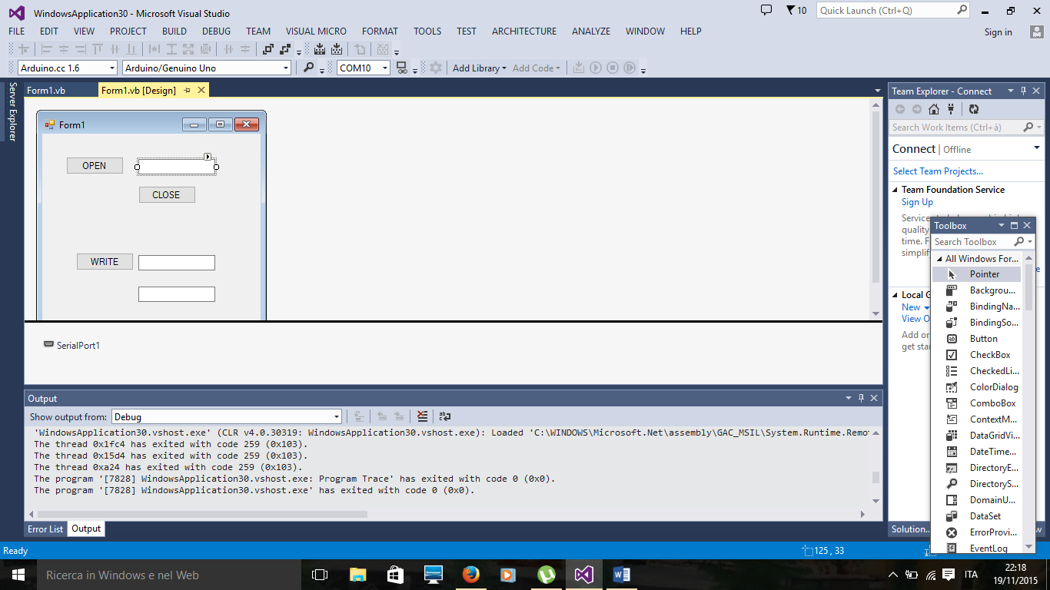

Public Class Form1

Private Sub Button1_Click(sender As Object, e As EventArgs) Handles Button1.Click
SerialPort1.PortName = TextBox1.Text
SerialPort1.Open()
End Sub

Private Sub Button2_Click(sender As Object, e As EventArgs) Handles Button2.Click
If SerialPort1.IsOpen = True Then
SerialPort1.Close()
End If
End Sub

Private Sub Button3_Click(sender As Object, e As EventArgs) Handles Button3.Click
If TextBox2.Text.Length = 0 Then ' Error if there is no send data
MessageBox.Show("String input error")
', MessageBoxButtons.OK, MessageBoxIcon.Error)
Exit Sub ' Break out of processing
End If

Try
SerialPort1.WriteLine(TextBox2.Text) ' Write data to the send buffer
Catch ex As Exception ' Exception handling
MessageBox.Show(ex.Message, "Error", MessageBoxButtons.OK, MessageBoxIcon.Error)
End Try
End Sub

Private Sub Form1_Load(sender As Object, e As EventArgs) Handles MyBase.Load

End Sub
'Declare a delegate
Delegate Sub DataDelegate(ByVal sdata As String)

'Define the method (function) that will be called by the Invoke method
Private Sub PrintData(ByVal sdata As String)
TextBox3.Text = sdata
End Sub

Private Sub SerialPort1_DataReceived() ' : Code the processing when the data received event occurs
Dim ReceivedData As String = " " ' Declare variable for received data
Try
ReceivedData = SerialPort1.ReadLine ' Receive the data
Catch ex As Exception
ReceivedData = ex.Message ' Exception handling
End Try
' Declare delegate to method to execute by Invoke method and display received data
Dim adre As New DataDelegate(AddressOf PrintData)
Me.Invoke(adre, ReceivedData)

End Sub

End Class

